LAB Assignment

Topic: WireShark Lab-02

Submitted to -
Dr. Md. Shariful Islam
Professor
IIT, University of Dhaka

Submitted by -
Shah Alam Abir
Roll : BSSE-1439
IIT, University of Dhaka
1. The Basic HTTP GET/response interaction

- My browser is running HTTP version 1.1.
Server is running HTTP version 1.1.
- Accept-Language: en-US,en;q=0.5\r\n
- IP of my device: 192.168.0.104
IP of server: 128.119.245.12
- Returned status code from browser to my device is : 200.
- Last-Modified: Sun, 24 Sep 2023 05:59:02 GMT\r\n
- 540 bytes of content are being returned to my browser
- There is no header within the data that are not displayed in the packet-listing window.

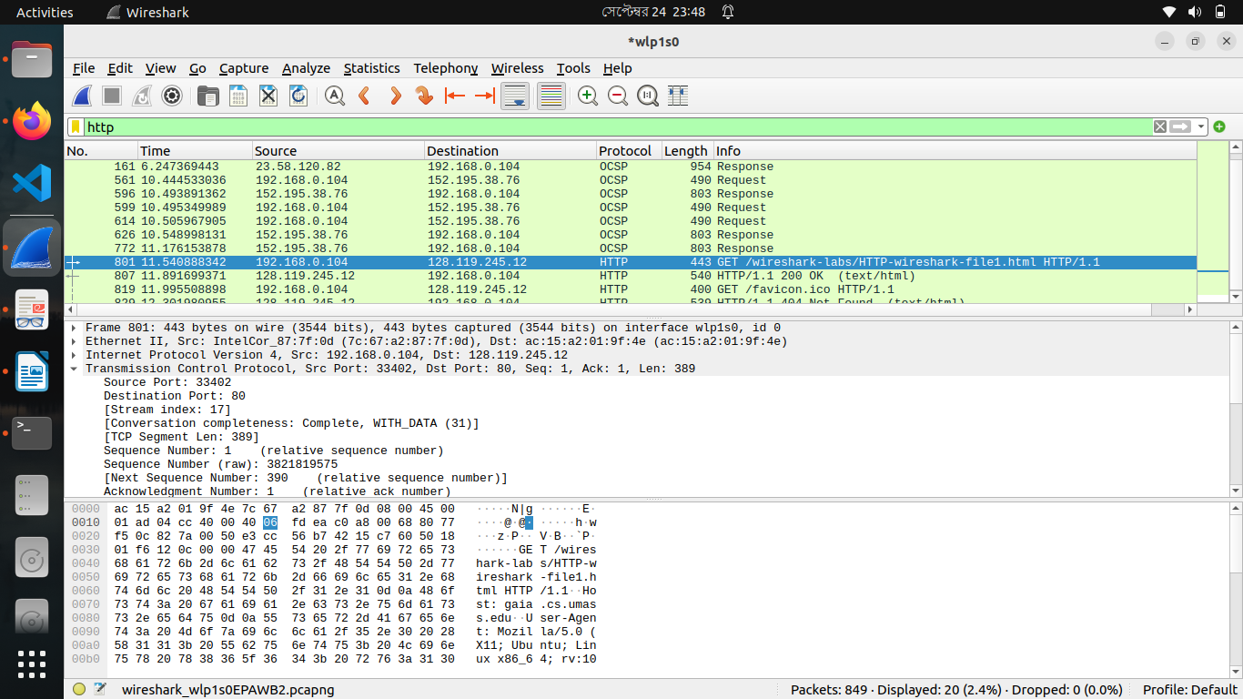

2. The HTTP CONDITIONAL GET/response interaction

- No, there is no “IF-MODIFIED-SINCE” line in the first HTTP GET request.
- YES, the server explicitly return the contents of the file. We can say this because of status code 200 OK. Also, there is a “Line-based text data” field where returned data is written.
- Yes, there is a “IF-MODIFIED-SINCE” line in the second HTTP GET request. If-Modified-Since: Sun, 24 Sep 2023 05:59:02 GMT\r\n
- No, the server didn’t explicitly return the contents of the file. We can say this because of status code 304 Not modified. Also, there is no “Line-based text data” field where returned data would be written.

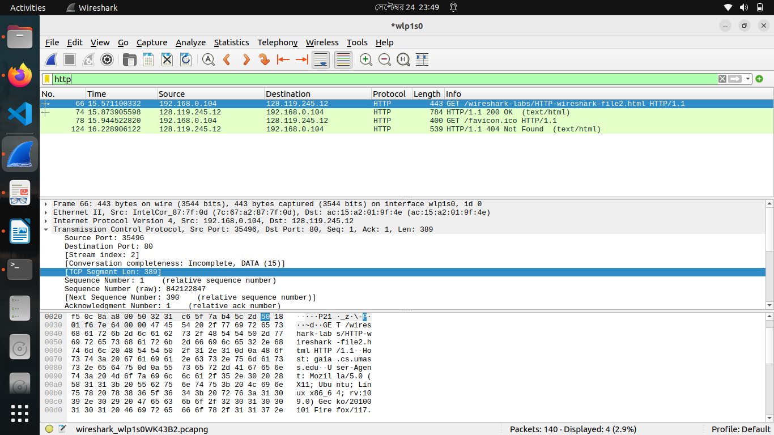
3. Retrieving Long Documents

- There is 2 HTTP GET request messages sent by my browser. Packet no. 258 in the trace contains the GET message for the Bill of Rights.
- 13. Packet no. 258 & 287 in the trace contains the status code and phase associated with the response to the HTTP GET request.
- In 258, Status Code: 200 OK
In 287, Status Code: 404 Not Found
- There are 4 data-containing TCP segments needed to carry the single HTTP response and the text of the Bill of Rights.

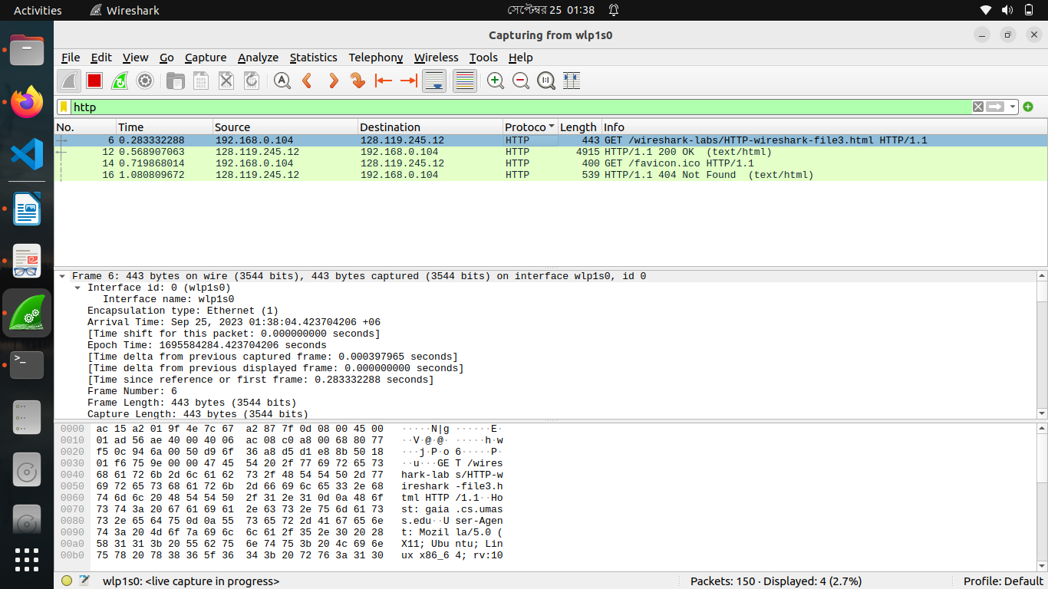

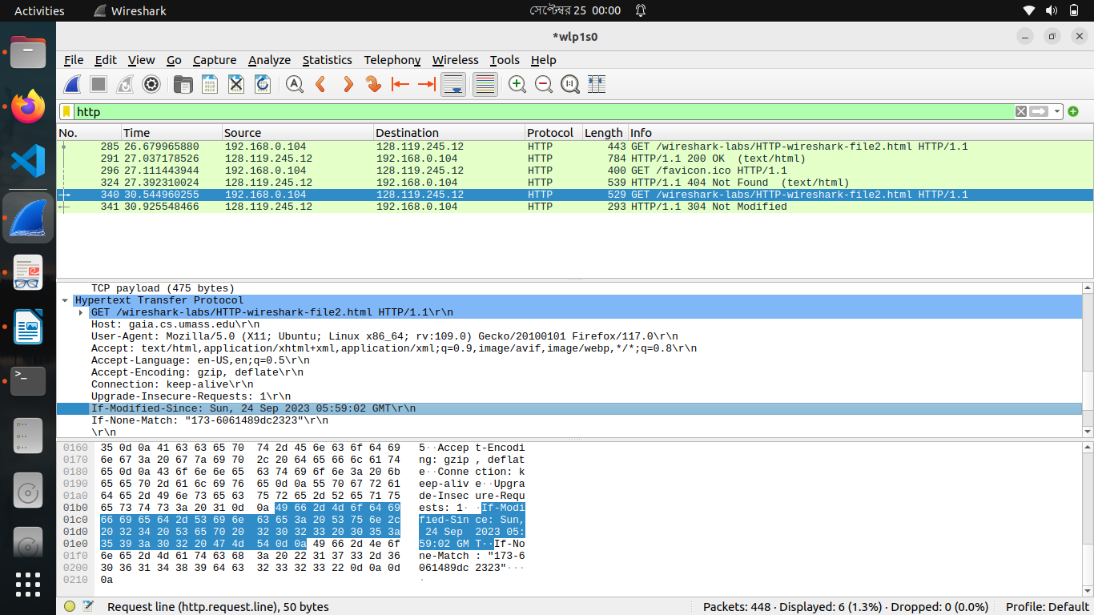

4. HTML Documents with Embedded Objects

- There are 4 HTTP GET requests. Request HTTP addresses are:
- http://gaia.cs.umass.edu/wireshark-labs/HTTP-wireshark-file4.html
- http://gaia.cs.umass.edu/pearson.png
- http://gaia.cs.umass.edu/favicon.ico
- http://kurose.cslash.net/8E_cover_small.jpg

- Here, first of all 1 GET request and 1 response found here. Then, 3 get requests were sent parallel, then responses came one by one. That’s why we can say that my browser were downloaded from the two web sites in parallel
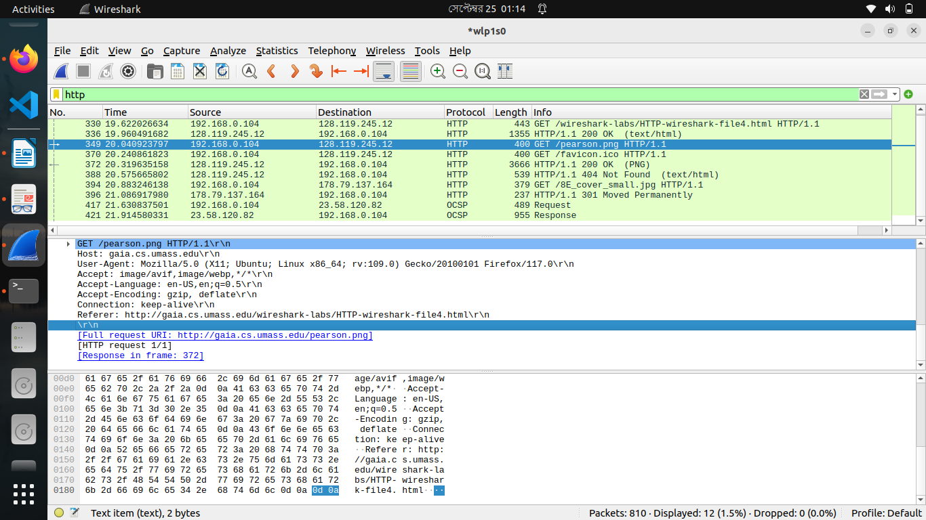

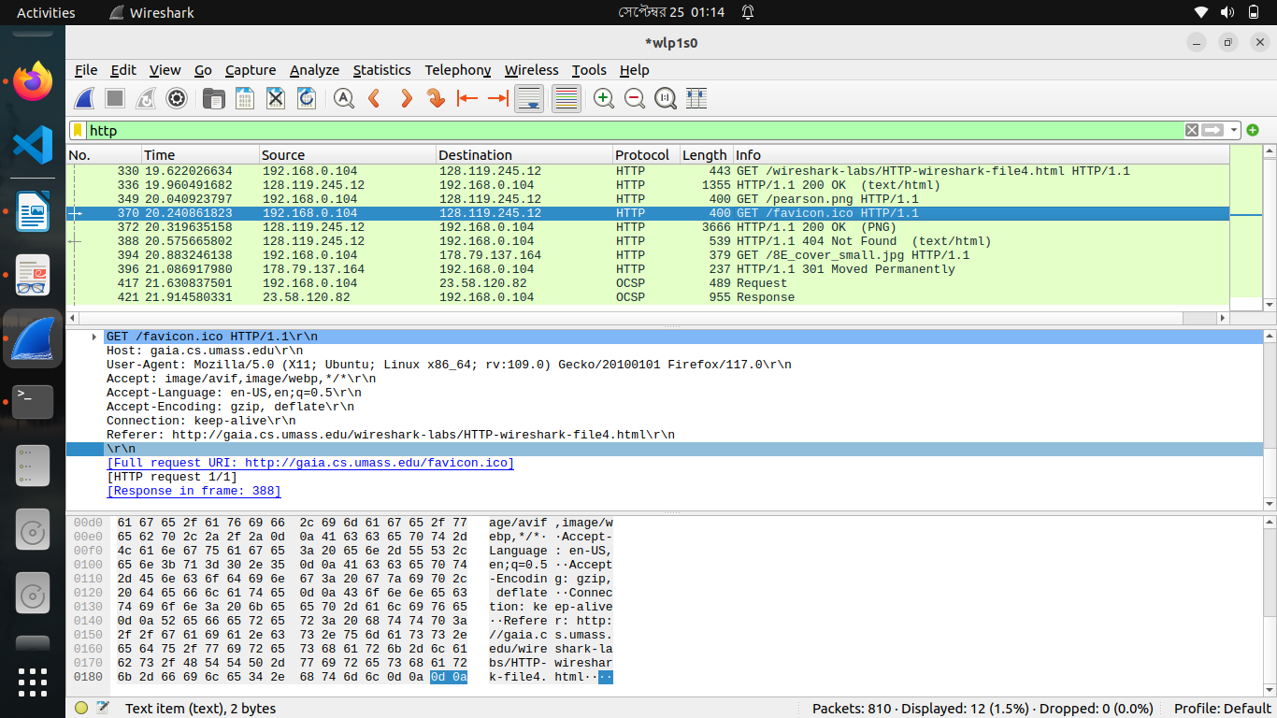
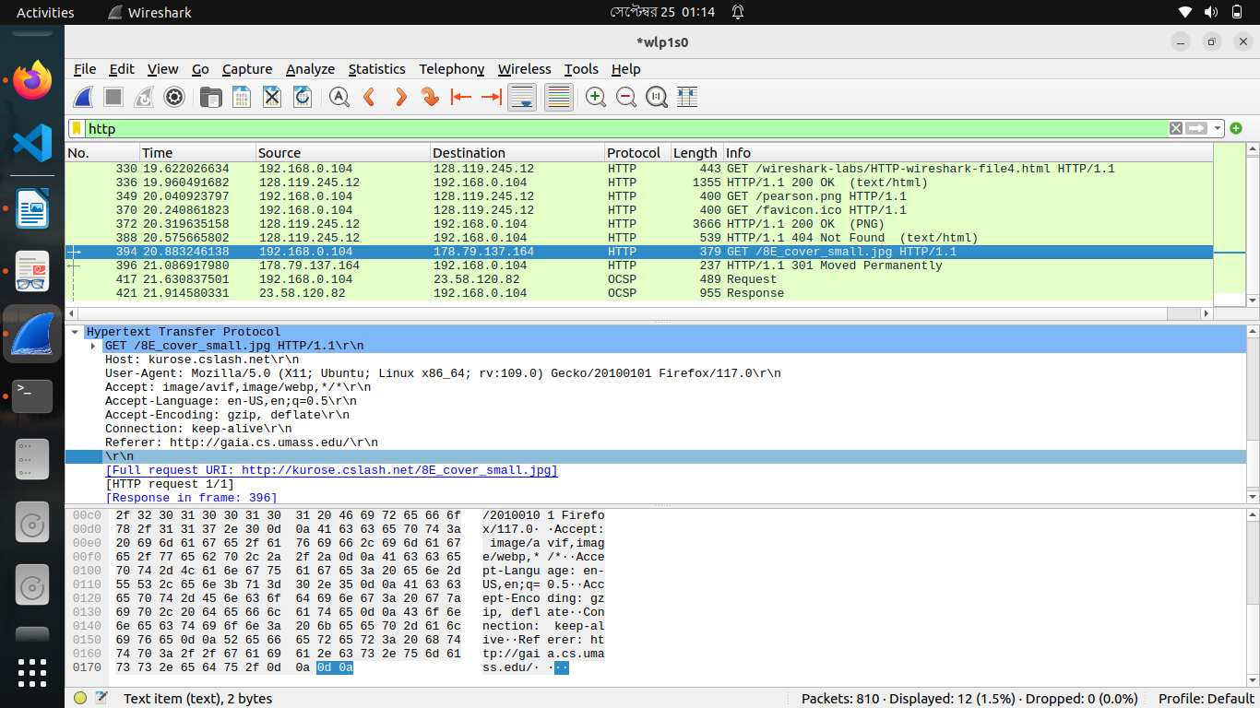

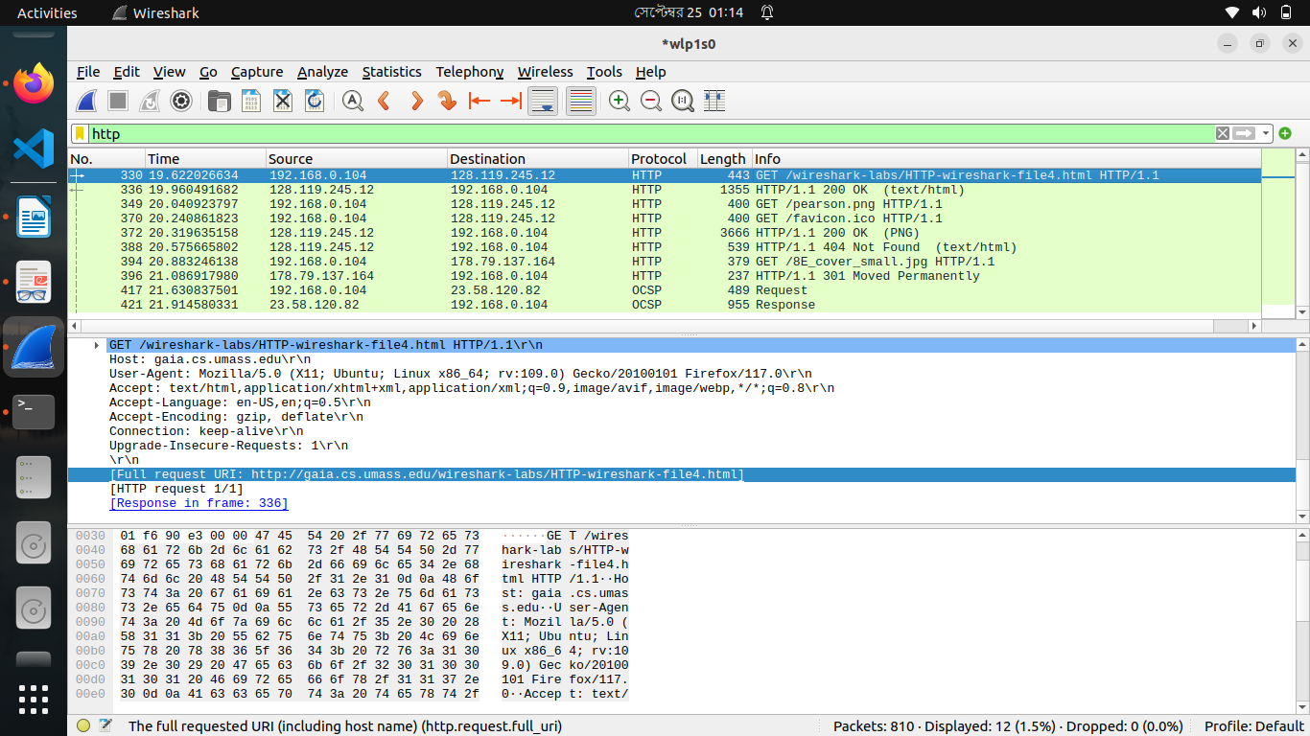
5 HTTP Authentication
- Server’s response status code was 401 & status phase was “unauthorized”

